**Setting up Kafka Cluster**

About: Open source for building messaging and streaming services

* Small events, eliminates batch jobs (associated with data loss)
* Low latency

Amazon Managed Streaming for Apache Kafka (MSK)

* Easiest approach
* Managed service that manages the operational overhead
* **Create a Cluster** via AWS Console or CLI (Command Line)

From The Console

*Cluster Settings*

1. Go to services and select “MSK”
   1. Graphical user interface, text, application

      Description automatically generated
2. Click on “Create Cluster
   1. Graphical user interface, application

      Description automatically generated
3. Select “Quick Create” or “**Custom Create**”
   1. Quick Create – best for starter cluster, automates certain preferences
   2. Custom Create – gives full access to specify all settings
4. Name the Cluster
5. Select **“Provisioned”** or“Serverless”
   1. Serverless – AWS auto scales broker size for you
   2. Provisioned – allows you to determine the number/size of brokers (determines performance)
6. Select Kafka version type
   1. Graphical user interface, text, application, email

      Description automatically generatedopt for most recent
7. Brokers
   1. Select a broker type (determines compute capability)
   2. Select a # of Availability Zones (AZ)
   3. Select # of brokers for each AZ
8. Storage
   1. Choose EBS Storage per Broker
      1. Note* Storage can be increased but **cannot be decreased** after creation
9. Select Default Configuration or Custom Configuration

*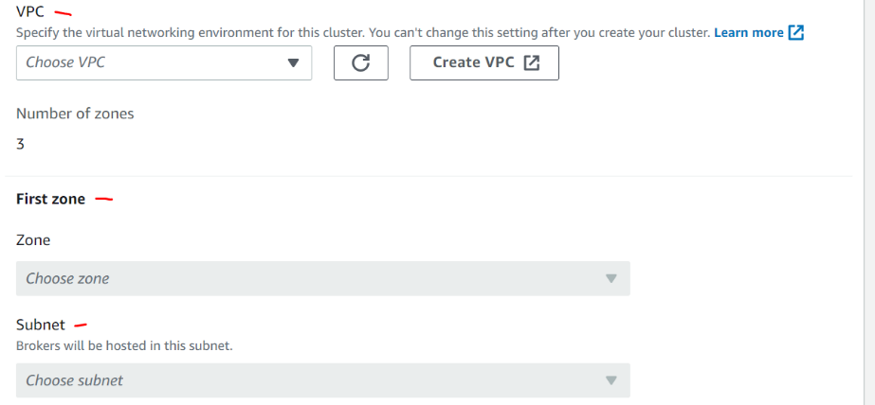Networking Settings*

1. Select the **VPC** you will be deploying in – your virtual network environment
   1. Note* This **cannot be changed** after creation
2. Next, select **Availability Zones** (AZs) and corresponding **Subnets** for Brokers to be deployed in
3. Select “Security Group’s”
   1. Allow groups of resources to have the same inbound/outbound rules/policies

*Security Settings*

1. Access Control
   1. Select an access control option
      1. Unauthenticated – no controls
      2. IAM – identifies users and gives specific role-based policies
2. Encryption
   1. Select “TLS Encryption” between clients and brokers
      1. This is required when using IAM
   2. Encryption data at rest
      1. Use AWS managed key – created/monitored by AWS
      2. Use Customer managed key – created/monitored by the customer

*Monitoring and Tags*

1. Enable “CloudWatch Basic” or an enhanced version
   1. Will monitor your usage and give reports on your resources in AWS (brokers, clusters)
2. Graphical user interface, text, application, email

   Description automatically generatedCluster Tags
   1. Add key-value pairs for your resources
   2. Allows you to group certain resources together
3. Review your preferences/selections are correct and click **“Create Cluster”** for official creation
   1. Note*: The following categories cannot be edited after creation of the Cluster
      1. Cluster Type
         1. Serverless or Provisioned
      2. VPC
      3. Subnets
      4. Security Groups
      5. Access Control Method
         1. IAM, Unauthenticated, etc.